# Project: Leave Record Management

# Description: In schools, college Student and teachers take some leave for specific work. This project design and develop to maintain a record of their taken leave in institute.

# Created By: Somesh Mishra

**Email Id:** [mishra.somesh47@gmail.com](mailto:mishra.somesh47@gmail.com)

**Contact Number: 8962616747**

**LinkedIn: https://www.linkedin.com/in/somesh-mishra-a99a5b117**

# 

# Source

1. Fseek: - The function fseek set the file pointer associated with a stream to a new position. The parameters are described bellow in below table.

Declaration - int fseek (FILE *Stream, long offset, int whence)

|  |  |
| --- | --- |
| ARUMENTS | MEANING |
| Stream | Stream whose file pointer fseek set. |
| Offset | Difference in byte between whence (a file pointer position) and the new position for text mode stream offset should be 0 or a value returns by ftell. |
| Whence | One of three SEEK_XXX file pointer position |

|  |  |  |
| --- | --- | --- |
| CONSTANT | VALUE | FILE LOCATION |
| SEEK_SET | 0 | Seek from beginning of file |
| SEEK_CUR | 1 | Seek from current position |
| SEEK_END | 2 | Seek from end of file |

# RETURN VALUE: - SUCCESS - 0

**FAILURE - 1 or NON ZERO value**

1. **Fwrite :-**

# Algorithm

**Main function**

**Steps**

1. Start with welcome screen
2. Get password from user
3. Check password. Is password correct

Yes:-goto step 4

No:-print wrong message and goto step 2

1. Display mainmenu as below

* 1.add leave record
* 2.delete leave record
* 3.search leave record
* 4.view today leave record
* 5.view all leave record
* 6.edit leave record
* 7.close application

1. Get choice from user

Choice:-1 call function addlv

Choice:-2 call function dltlv

Choice:-3 call function srchlv

Choice:-4 call function edtlv

Choice:-5 call function todylv

Choice:-6 call function allv

Choice:-7 goto step 6

6. Stop

**Addleave function**

**Steps**

1. Call Checkid function.

Return 1: Print message “Record already present do you want to modify (y/n)

Yes: step 1

No: mainmenu function

Return 0: step 2

2. Declare file pointer ‘fp’

3. Open file ‘fp’ to write

4. Assign the pointer to the end of the file to write

5. Get data from user

6. Write input data on a file

7. Close file

8. Print option to add another leave record

Yes:-goto step 1

No:-go back to main menu

**Deleteleave function**

**Steps**

1. Get choice from user

Choice: - 1 1. Get student enrollment number from user to delete

2. Declare file pointer ‘ft’

3. Open file ‘fp’ to read

4. Assign the pointer to the beginning of the file to be read

5. Loop until ‘End of file’ is not encountered read data from file.

6. Is user input enroll no. = enroll no. on a file

Yes: - A. Open ‘ft’ file and copy all data of ‘fp’ file in ‘ft’file except that data which we want to delete

B. delete ‘fp’ file and rename ft file by ‘fp’ file name and goto step 7

No:-print error message and close file and go back to main menu

7. Close file

8. Print option to delete another book

Yes:-goto step1

No:-go back to main menu

Choice: - 2 SAME AS CHOICE 1

**SearchLeave function**

**Steps**

1. Display option for search

* 1. Search by enrollment no.
* 2.Search by name

1. Open the fie ‘fp’ to read
2. Assign the pointer to the beginning of the file to be read
3. If option is search by enrollment no.

* Get student enrollment number from user
* Loop until ‘End of file’ is not encountered read data from file
* Is user input enroll no. =enroll no. on a file

Yes: - Display all information about that student’s enroll no. and goto step 6

No: - Print sorry message and goto step 6

1. If option is search by name

* Get student’s name from user
* Loop until ‘End of file’ is not encountered read data from file
* Is user input name= name on a file

Yes:-display all information about that student’s leave record and goto step 6

No:-print sorry message and goto step 7

1. Close file
2. Display option to search another book

Yes:-goto step 1

No: - go back to main menu

**TodaysLeave function**

**Steps**

1.Open the fie ‘fp’ to read

2 Assign the pointer to the beginning of the file to be read

3.Get date – month – year from user

* Loop until ‘End of file’ is not encountered read data from file
* Is user input date-month-year = date-month-year on a file

Yes:- Display all information about that student and goto step 6

No:- Print sorry message and goto step 4

4.Close file

**ViewLeavefunction**

**Steps**

1. Open ‘fs’ file
2. Assign the pointer to the beginning of the file to be read
3. Loop until ‘End of file’ is not encountered read data from file
4. Display list of all leave records with complete information
5. Show total number of leave in the record
6. Close file
7. Go back to main menu

**Editbook function**

**Steps**

1. Display option for search

* 1. Search by enrollment no.
* 2.Search by name

1. Open file ‘fs’
2. Assign the pointer to the beginning of the file to be read
3. If option is search by enrollment no

* Get enrollment no. from user
* Loop until ‘End of file’ is not encountered read data from file
* Is user input roll no. =roll no. on a file

Yes:- a. Get new data from user of that student which to be edited

b. Assign the pointer to the current position

c. Overwrite the new data on old data of that book and goto step 4

No:- Print sorry message and goto step 4

1. Close file

1. Display option to edit another record

Yes:-goto step 1

No:-goto step 6

1. Go back to main menu

**Getdata function**

**Steps**

1. Print “Enter information below”
2. Get Branch, Semester, Enrollment No, Name and Date will automatic assign in file by time function calling.
3. Go back to main menu

This function gets data from the user for all information of student.

**Password function**

**Steps**

1. Declare two string ‘pass’ and ‘ password=bunny’
2. Print “Enter the password”.
3. Until user entered the enter key get character for user
4. Store input character in string ‘pass’
5. Compare two string ‘pass’ and ‘password’ .Is both equal

Yes:-goto step 6

No:-print error message and get input from user to rewrite or exit.

6. Print password match message

7. Goto main menu

**Checkid function**

**Steps**

1. Assign the pointer to the begning of a file to read.
2. Loop until “ End Of File” is not encountered read data from file.
3. If user input enrollment no. = enrollment no. on afile
4. If today’s date = date on a file.

Yes :- return 1;

No :- return 0;

This function check whether the user input enrollment is exits in a file or not by today’s date.

**Program Output**

1. **Start with welcome screen.**

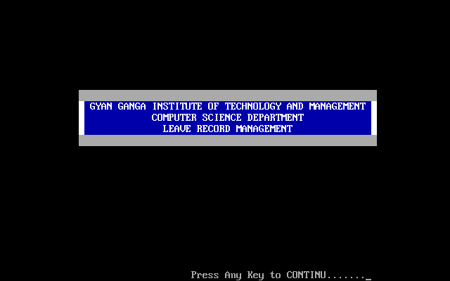

1. **Get password from user**.

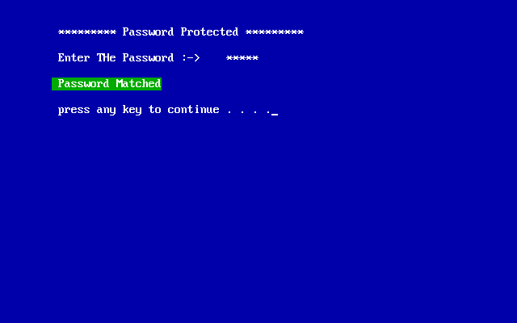

1. **Get choice from user in MAINMENU.**

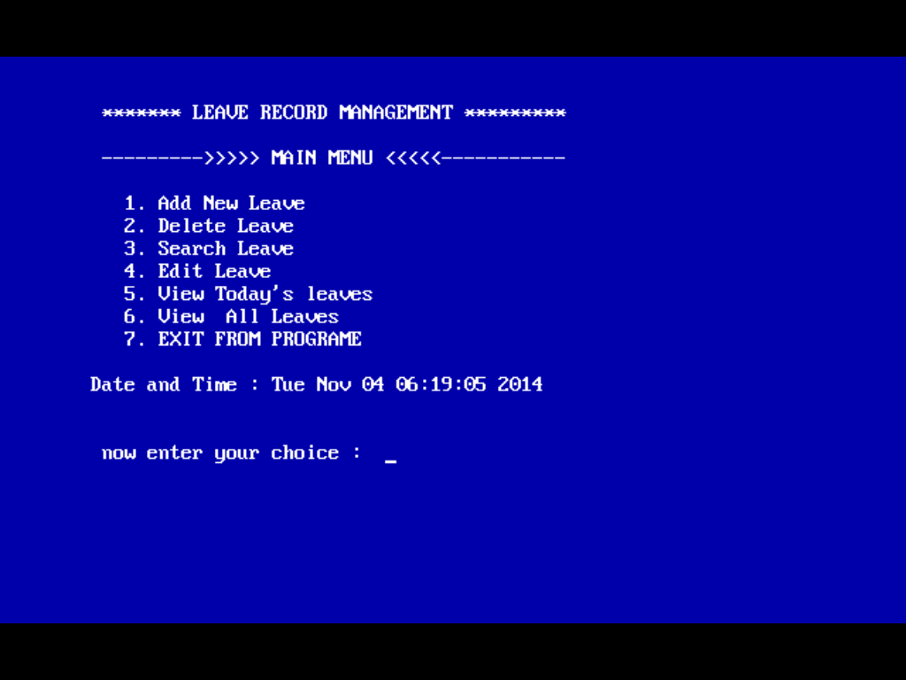

1. **Choice 1 :- Add New Leave :- check Enrollment No. exits in record or Not. by today’s date.**

**Yes :- see the below screen sort.**

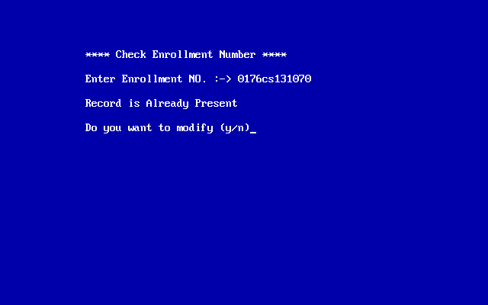

**No :- see the below screen sort.**

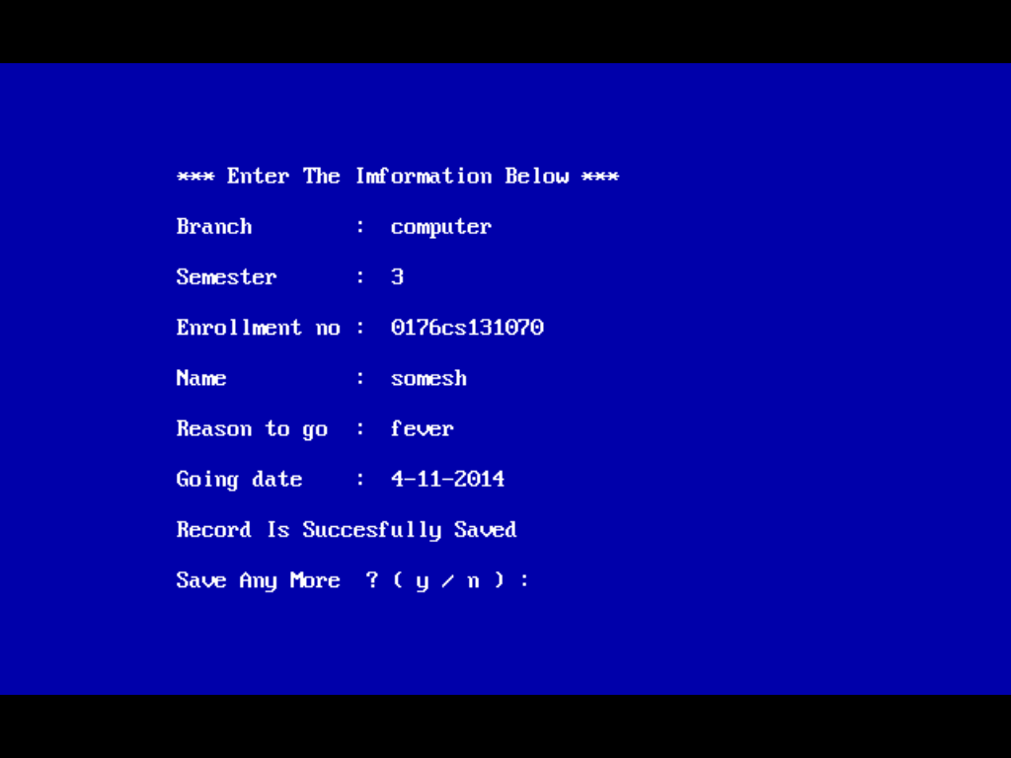

1. **Choice 2 :- Delete Leave**

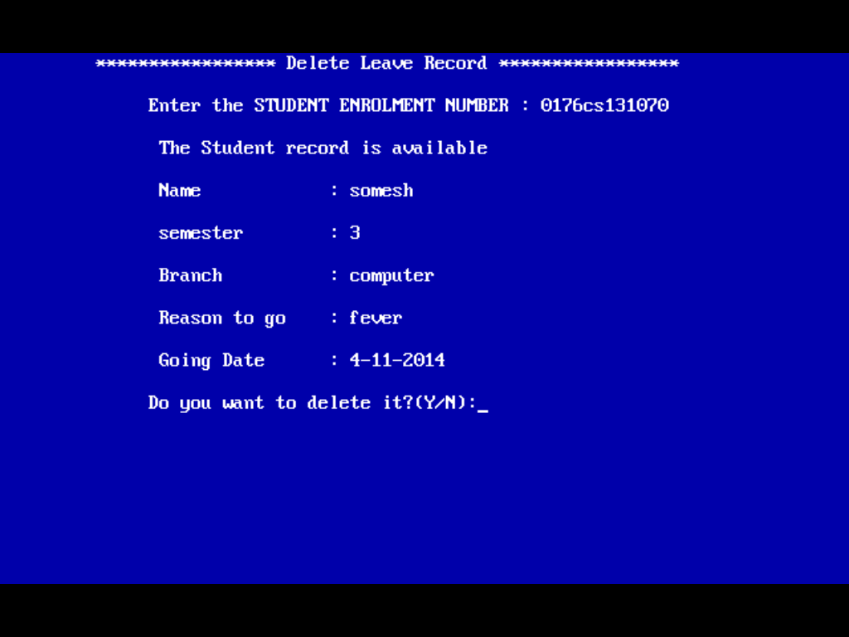

1. **Choice3 :- Search Leave**

**Get choice from user**

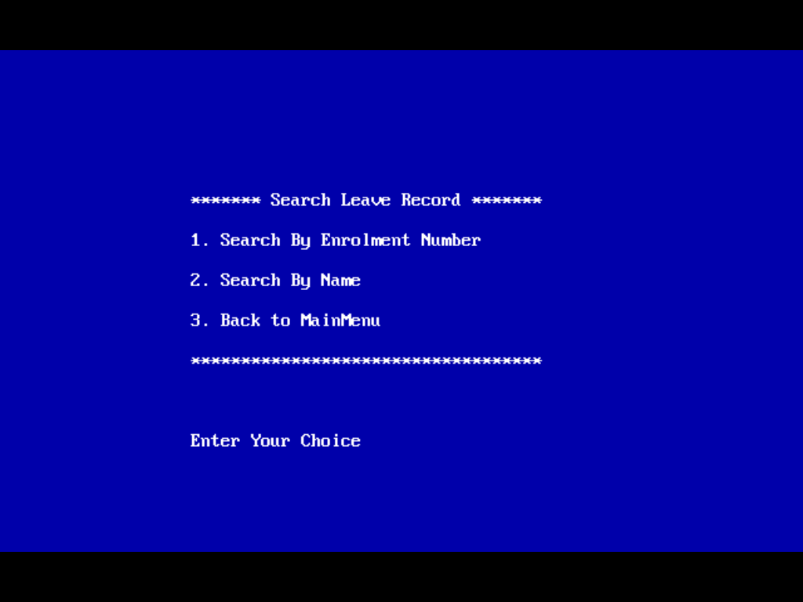

**If choice is Search by Enrollment Number**

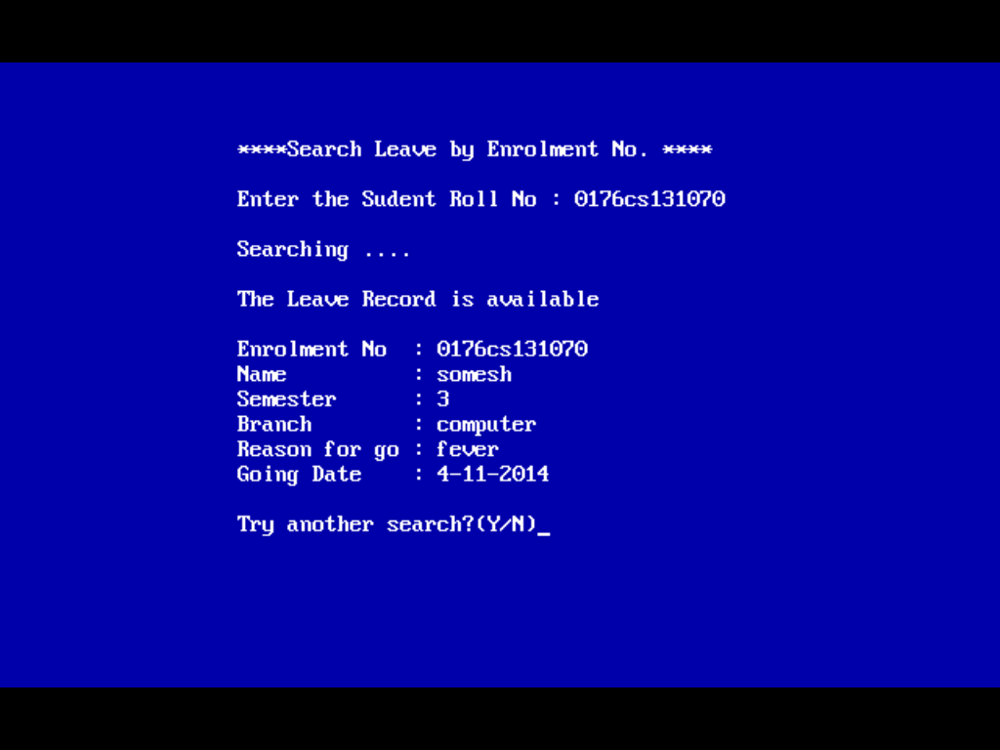

**If choice is Search by Name then it takes the name in place of Enrollment Number from User and Print the al Information of the Student**

1. **Choice 4 :- Edit Leaves**

**Get choice from user**

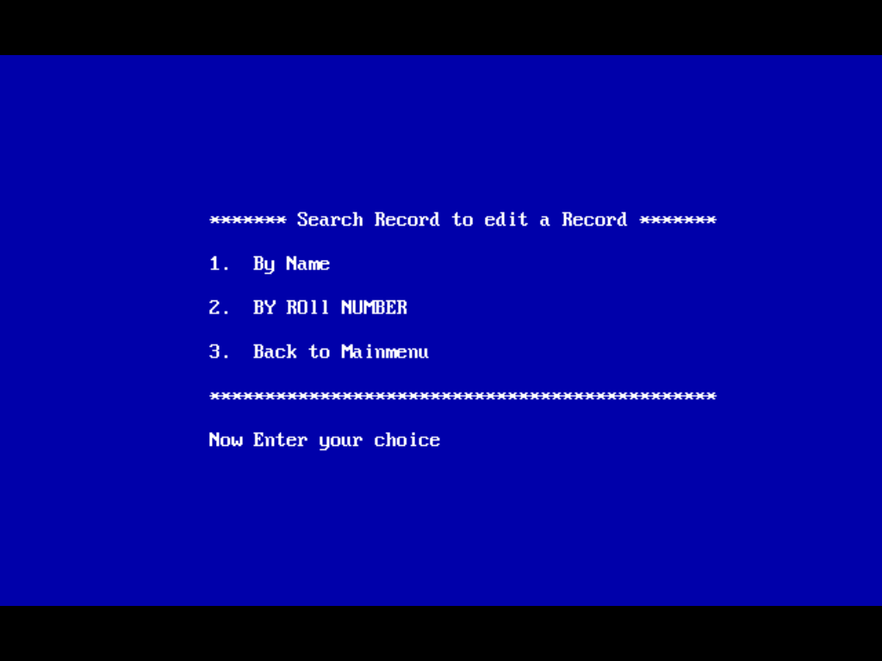

**If choice of user is BY NAME = somesh**

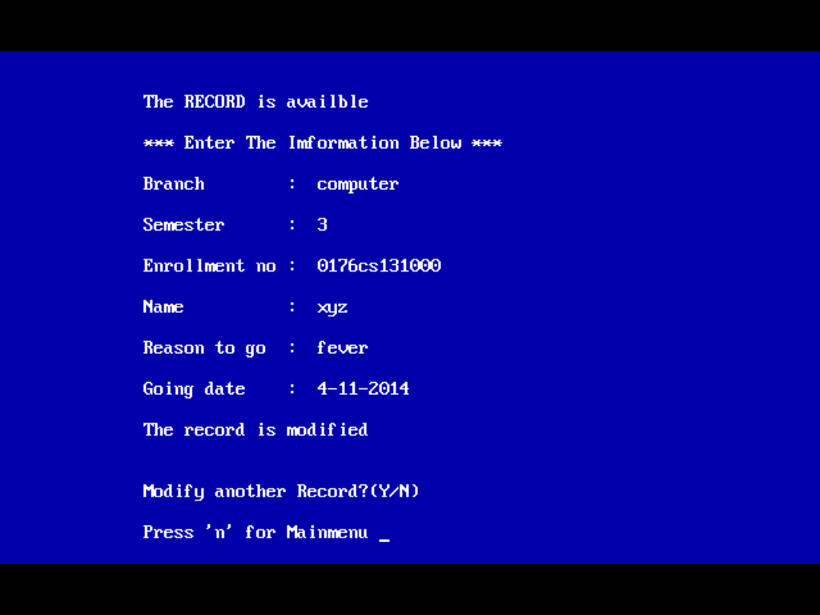

**And same as User selected choice is by Roll Number.**

1. **Choice 5 :- View Today’s Leave**

**It takes DATE-MONTH-YEAR as input from user**

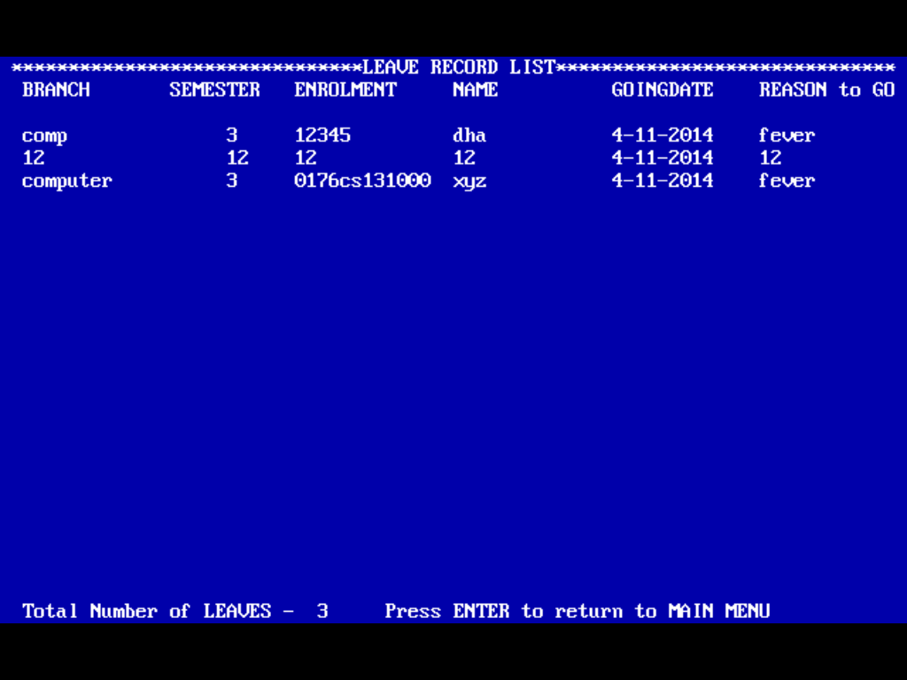

1. **Choise 6 :- View All Leaves**

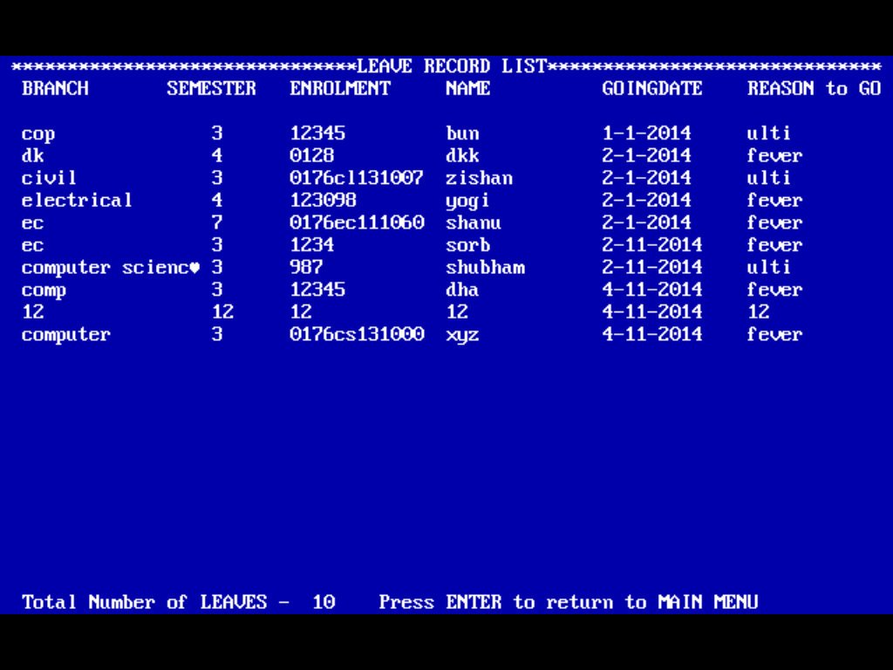

1. **Choice 7 :- Exit From Program**

